MEADOW LAKE, SOMERLEY ESTATE REPORT FOR 2024
by Brenda Cook
Thank you to Dimitri Moore for allowing me to use some of his photos.

This is my second year of my Spring/Autumn/Winter ringing at Meadow Lake.

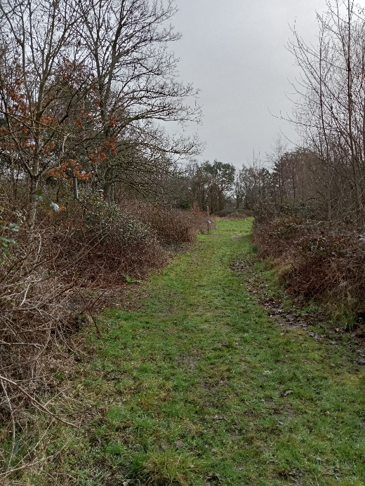

The first session in the new year took place on 6.1.24. We caught 78 birds of 13 different species. I kept a good number of feeders topped up with a selection of different food between the mist netting sessions. This was to encourage the birds to keep coming to the area. This easily available food not only encouraged different species to come, but also helped them to maintain their weight ready for the breeding season. On the morning of a ringing session small handfuls of seed were scattered on the ground close to the net to encourage the ground feeding birds to come closer and then hopefully fly into the net. This resulted in us catching a Brambling, Chaffinch, Reed Bunting, Dunnock, Song Thrush, Blackbird and Woodpigeon.
John kindly gave us permission to do 2 sessions a month as long as the weather was suitable.
On 16.3.24 Heidi Styles, Nicholas Watkins and myself caught 84 birds. There was 44 Siskin amongst the catch and one of these was a CONTROL. This is a bird ringed at least 5km away from where it is re-trapped.
ATY1043 SISKI 6M ringed 23.5.2022 at Peebles, Scottish Borders, (30 minutes from Edinburgh) a duration of 663 days distance 539 km.
We also caught a new species for the site a 5F Kestrel.
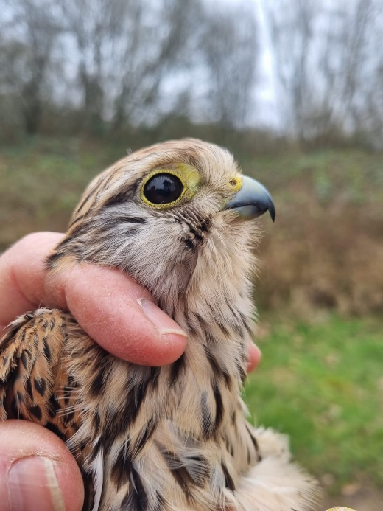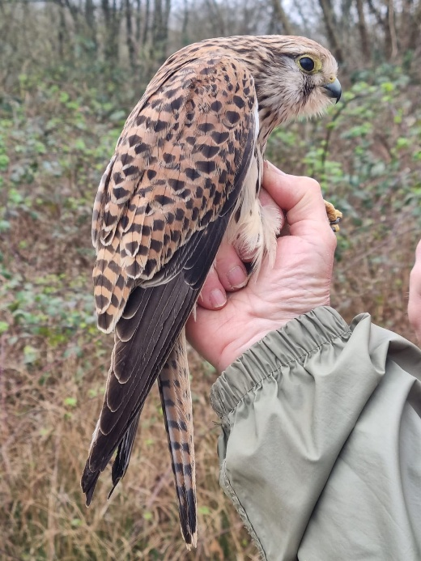
We managed to fit in 6 Spring sessions, the last one being on 31.3.24.
In the Autumn of 2024, our first mist netting session took place on 28.9.24. At this time of year, the breeding season has finished and so we are able to use calls/songs of certain species to attract them to visit the area. On this day we caught 28 birds of 12 different species. This was a great start, as all of them were new birds. Our second session produced a catch of 49 birds with 10 different species.
YR (young Ringed)
IP (in pin) and FS (feathers short) these are the codes for the stages the wing has reached. Both stages are ideal to ring the nestlings.
AGES:
1 pullus (nestling)
3 definitely hatched during current calendar year (first years in
Autumn)
4 hatched before current calendar year-exact year unknown (many
Adults in the autumn)
5 definitely hatched during previous calendar year
6 hatched before last calendar year- exact year is unknown (many Adults in the Spring.)

The interesting re-traps caught on 26.10.24 can be found below:-
BHD4400 BLUTI (Blue Tit) 3 ringed as (1) by Nik Watkins on 11.5.24 in Blashford nest Box YN 20 from a brood of 8 at IP (in pin)
PT40157 GRETI (Great Tit) 3M ringed as (1) on 4.5.24 from a brood of 6 in Box 22 at IP.
We then had a little gap from ringing while I went away for my holiday.
On my return I put up a variety of feeders to attract the birds and this made a huge difference to numbers caught. On 9.11.24 we caught 109 birds. 93 of these were new birds. We were delighted to catch our first Kingfisher at Meadow Lake, a juvenile female born in 2024.
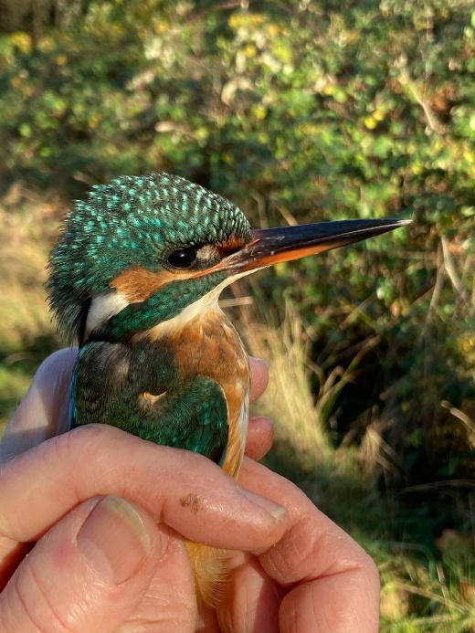

We also re-trapped the birds listed below:-
BHD4420 BLUTI which I ringed as (1) from a brood of 6 nestlings in Blashford Box 2 on 15.5.24.
Another interesting re-trap was a 3M Great Spotted Woodpecker. This had been caught in a net (during our CES Constant Effort Site mist netting project) close to the Lapwing hide at Blashford on 1.6.24.
We had another successful session on 29.11.24 when 72 birds were caught. We caught our second juvenile Kingfisher and re-trapped 4 birds which had been ringed during our winter mist netting in the Blashford Education Field:-
PT37398 GRETI 3F on 15.11.24 net 3.
BAE1557 BLUTI 3M on 3.11.24 net 3
BAE1742 BLUTI 3 on 26.11.24 net 3
BAE1449 BLUTI on 15.11.24 net 2
We also re-trapped BHD4420 BLUTI 3 from Box 2 which we had previously caught on 9.11 24.
We managed to fit in 2 sessions during December.
On 20.12.24, 71 birds were caught. A further 72 birds were caught on 27.12.24 with a new species of a Woodpigeon amongst the catch.
The interesting birds to add to my project from these 2 mist netting sessions listed below:-
NVT205 CHIFF(Chiffchaff) 4 ringed in the education field on 16.12.21 (3)
AJZ6780 BLUTI 4 ringed on 20.5.23 (1) from Box 41 YR 6/6 IP
AYC9923 BLUTI 4 ringed on 6.2.19 (5) Blashford Education Field
BHD4408 BLUTI 3 ringed on 11.5.24 (1) by Nik Watkins from Box 114 YR 8/8 FS
AYY4979 BLUTI 4 ringed on 20.12.22 (3) Blashford Education Field net 3
AYY4919 BLUTI 4M ringed on 1.12.22 (4) Blashford Education Field net 3
AJZ6589 BLUTI 4M ringed on 2.1.23 (5) Blashford Education Field net 1
AJZ6503 BLUTI 4M ringed 20.12 22 (3) Blashford Education Field net 3
PL06092 GRETI 4F ringed10.5.22 (1) from Box YN 17 YR 5/5 FS
The Meadow Lake area is a fantastic place for different bird species as has been proved by the number of birds caught at the site.

Here are a few photos of the species caught.

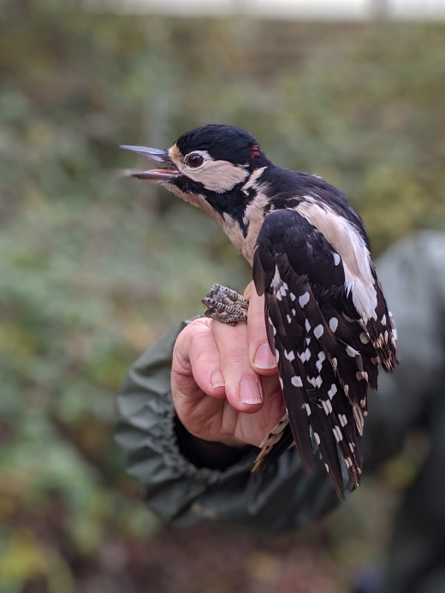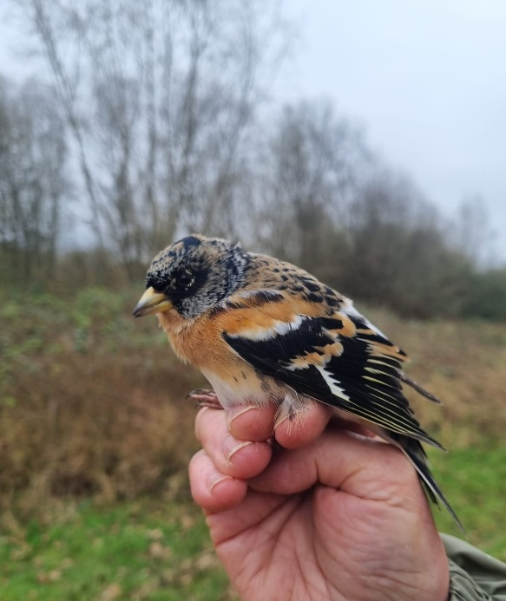
Great Spotted Woodpecker Brambling

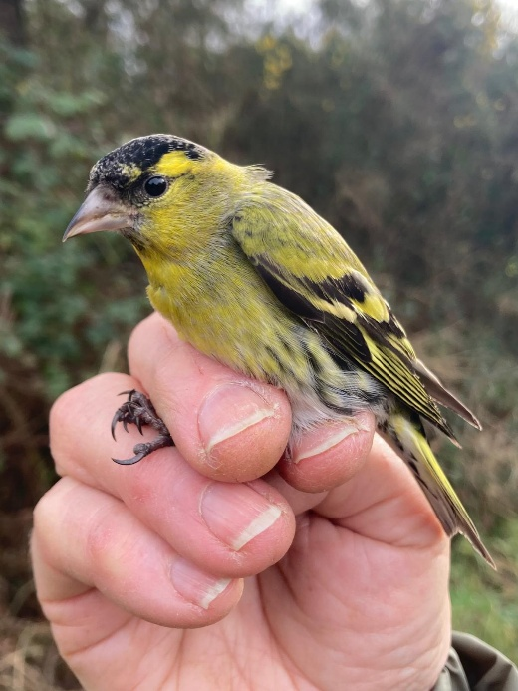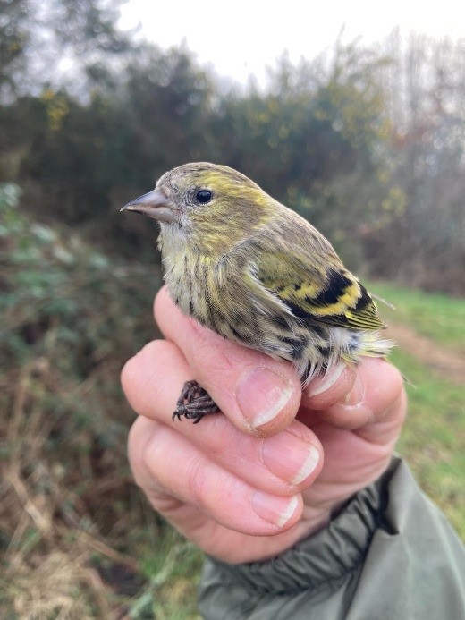
Male Siskin Female Siskin

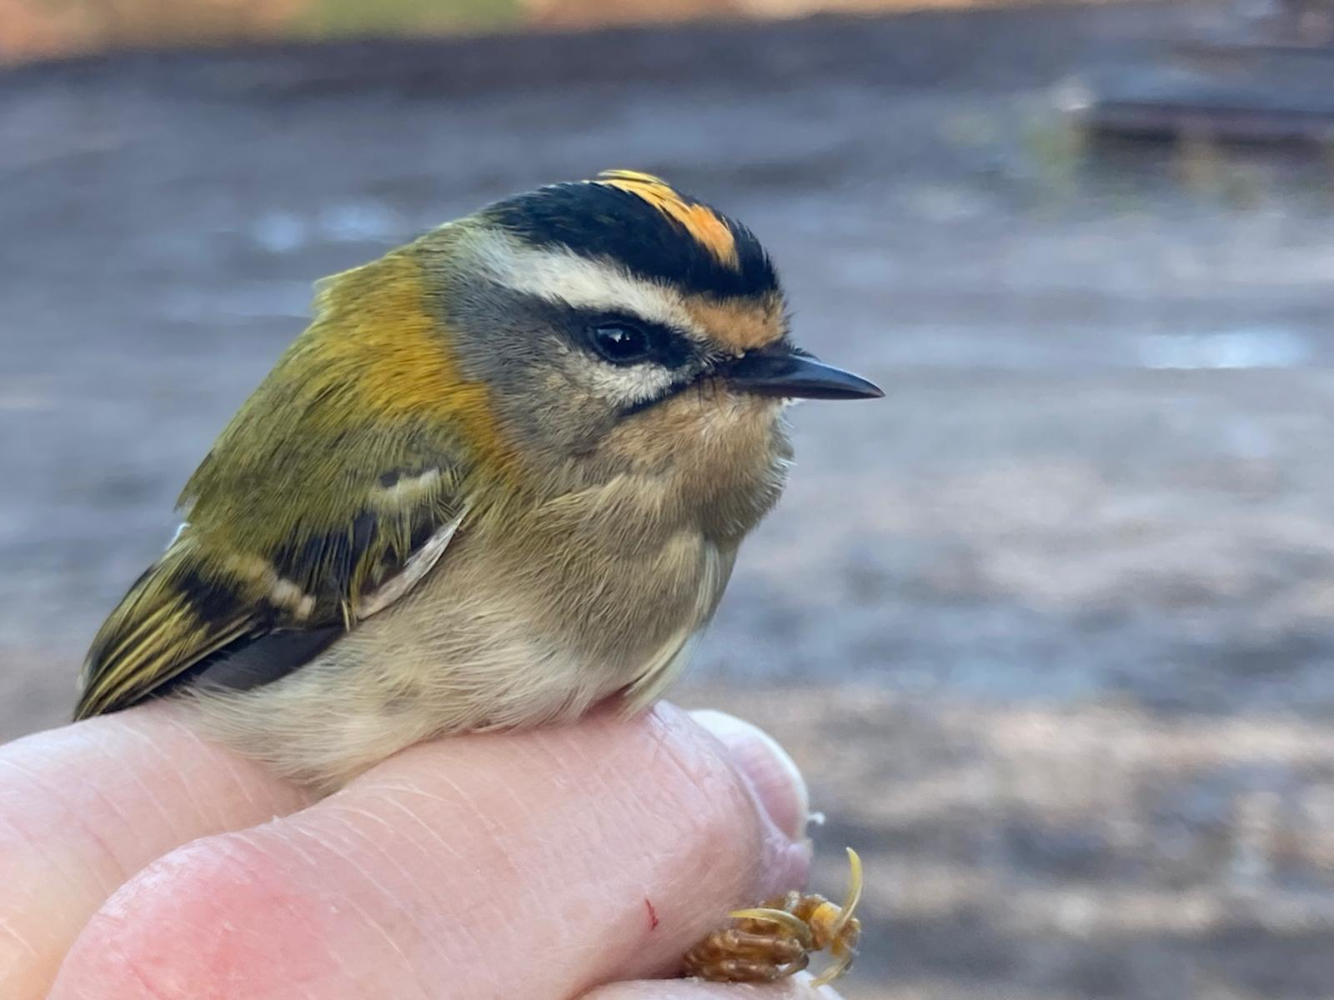
Male Firecrest

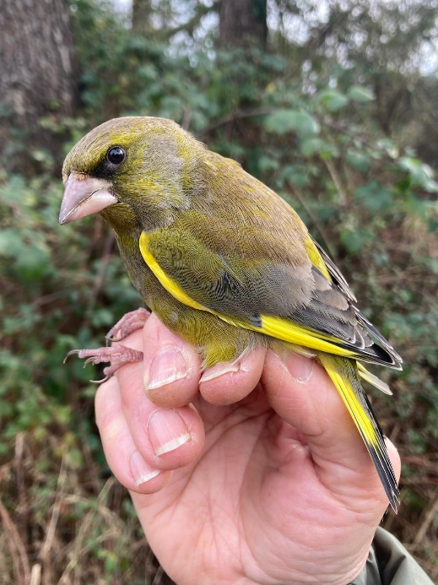
Male Greenfinch

The habitat in the area all around the lakes is so thoughtfully and well maintained by John Levell to encourage a variety of species at different times of year. There are different species of trees, bramble and grass areas with wild flowers providing seeds for winter food. These different habitats also provide places for the birds to nest and successfully rear their young.
The increase in numbers caught this year shows how well the birds are breeding.
The numbers of re-trap birds show us their survival rate.
I have also been pleased with the number of birds either just visiting the feeders from Blashford Lakes Reserve or I am sure in a lot of cases are making the Meadow Lake area their home.

Please see the charts below showing totals caught for 2023 and 2024.
N = New
S = Re-Trap
CHART 2023
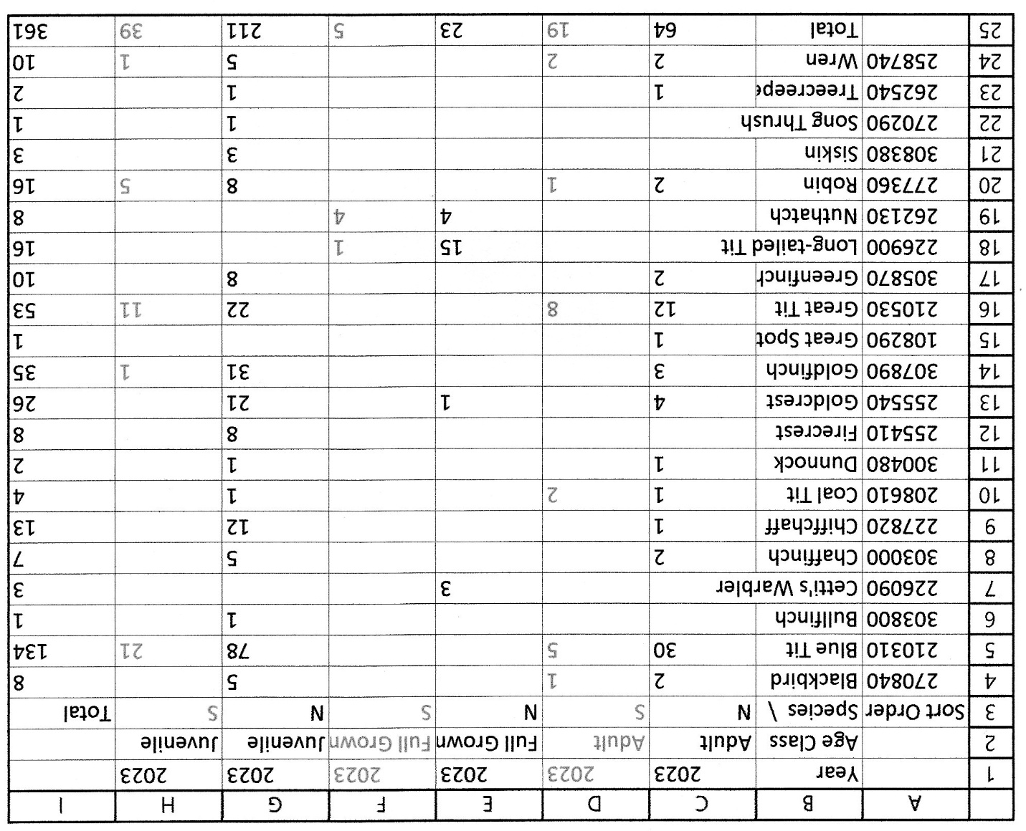

CHART 2024
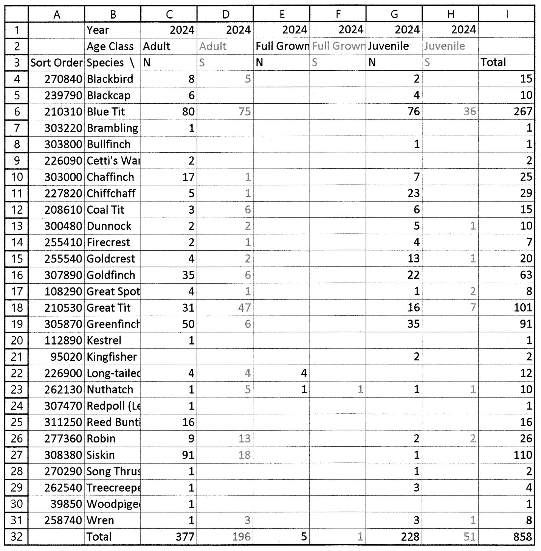

Comparison between 23 and 24

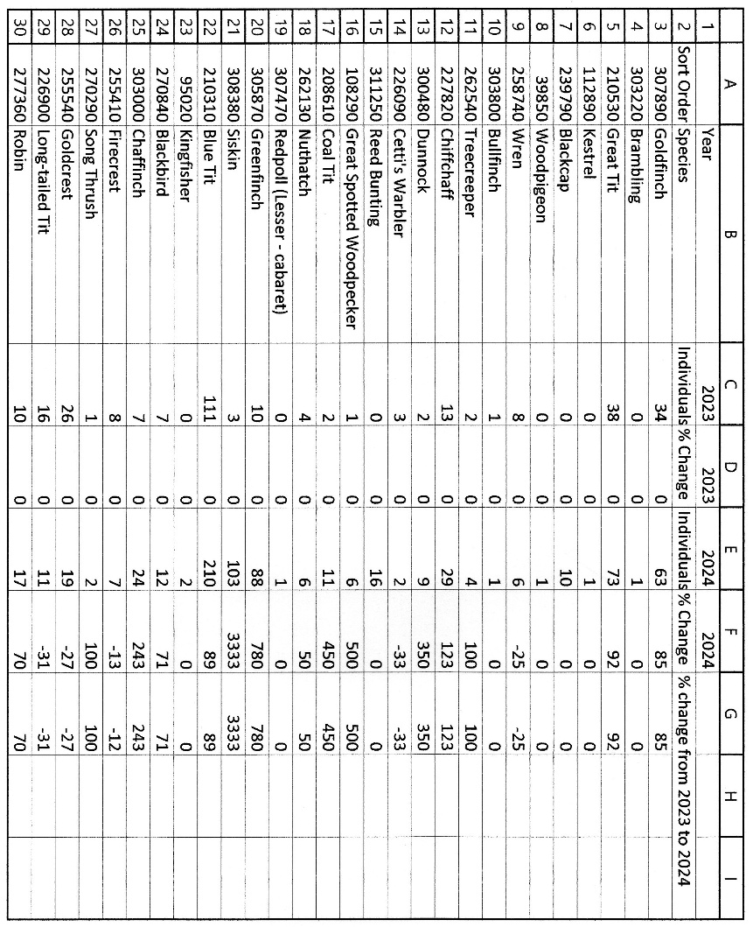

I would like to thank the Somerley Estate and John Levell for giving me permission to ring and showing such an interest in the birds we catch at Meadow Lake.

Thank you also goes to Kevin Sayer and Trainees Heidi Styles, Nicholas Watkins, Dimitri Moore, Peter Lackie, Ben Attwell Harry Britten, Kate Fry and visiting ringer Thomas Weston for their help at various sessions. Without their help we would have been unable to collect all this valuable data.

 |  |  |  |  |  |  |  |  |  |  |  |  |  |  |  |  |  |  |  |  |  |  |  | 2024 | 2024 | 2024 | 2024 | 2024
 |  |  |  |  |  |  |  |  |  |  |  |  |  |  |  |  |  |  |  |  |  |  |  | Adult | Full Grown | Full Grown | Juvenile | Juvenile
 |  |  |  |  |  |  |  |  |  |  |  |  |  |  |  |  |  |  |  |  |  |  |  | S | N | S | N | S | Total
 |  |  |  |  |  |  |  |  |  |  |  |  |  |  |  |  |  |  |  |  |  |  |  | 5 |  |  | 2 |  | 15
 |  |  |  |  |  |  |  |  |  |  |  |  |  |  |  |  |  |  |  |  |  |  |  |  |  |  | 4 |  | 10
 |  |  |  |  |  |  |  |  |  |  |  |  |  |  |  |  |  |  |  |  |  |  |  | 75 |  |  | 76 | 36 | 267
 |  |  |  |  |  |  |  |  |  |  |  |  |  |  |  |  |  |  |  |  |  |  |  |  |  |  |  |  | 1
 |  |  |  |  |  |  |  |  |  |  |  |  |  |  |  |  |  |  |  |  |  |  |  |  |  |  |  |  |  |  |  |  | 2023 | 2023 | 2024 | 2024
 |  |  |  |  |  |  |  |  |  |  |  |  |  |  |  |  |  |  |  |  |  |  |  |  |  |  |  |  |  |  |  |  |  | Species |  |  | Individuals |  |  | % Change | Individuals | % Change | % change from 2023 to 2024
 |  |  |  |  |  |  |  |  |  |  |  |  |  |  |  |  |  |  |  |  |  |  |  |  |  |  |  |  |  |  |  |  |  | Goldfinch |  |  | 34 |  |  | 0 | 63 | 85 | 85
 |  |  |  |  |  |  |  |  |  |  |  |  |  |  |  |  |  |  |  |  |  |  |  |  |  |  |  |  |  |  |  |  |  | Brambling |  |  | 0 |  |  | 0 | 1 | 0 | 0
 |  |  |  |  |  |  |  |  |  |  |  |  |  |  |  |  |  |  |  |  |  |  |  |  |  |  |  |  |  |  |  |  |  | Great Tit |  |  | 38 |  |  | 0 | 73 | 92 | 92
 |  |  |  |  |  |  |  |  |  |  |  |  |  |  |  |  |  |  |  |  |  |  |  |  |  |  |  |  |  |  |  |  |  | Kestrel |  |  | 0 |  |  | 0 | 1 | 0 | 0
 |  |  |  |  |  |  |  |  |  |  |  |  |  |  |  |  |  |  |  |  |  |  |  |  |  |  |  |  |  |  |  |  |  | Blackcap |  |  | 0 |  |  | 0 | 10 | 0 | 0
 |  |  |  |  |  |  |  |  |  |  |  |  |  |  |  |  |  |  |  |  |  |  |  |  |  |  |  |  |  |  |  |  |  | Woodpigeon |  |  | 0 |  |  | 0 | 1 | 0 | 0
 |  |  |  |  |  |  |  |  |  |  |  |  |  |  |  |  |  |  |  |  |  |  |  |  |  |  |  |  |  |  |  |  |  | Wren |  |  | 8 |  |  | 0 | 6 | -25 | -25
 |  |  |  |  |  |  |  |  |  |  |  |  |  |  |  |  |  |  |  |  |  |  |  |  |  |  |  |  |  |  |  |  |  | Bullfinch |  |  | 1 |  |  | 0 | 1 | 0 | 0
 |  |  |  |  |  |  |  |  |  |  |  |  |  |  |  |  |  |  |  |  |  |  |  |  |  |  |  |  |  |  |  |  |  | Treecreeper |  |  | 2 |  |  | 0 | 4 | 100 | 100
 |  |  |  |  |  |  |  |  |  |  |  |  |  |  |  |  |  |  |  |  |  |  |  |  |  |  |  |  |  |  |  |  |  | Chiffchaff |  |  | 13 |  |  | 0 | 29 | 123 | 123
 |  |  |  |  |  |  |  |  |  |  |  |  |  |  |  |  |  |  |  |  |  |  |  |  |  |  |  |  |  |  |  |  |  | Dunnock |  |  | 2 |  |  | 0 | 9 | 350 | 350
 |  |  |  |  |  |  |  |  |  |  |  |  |  |  |  |  |  |  |  |  |  |  |  |  |  |  |  |  |  |  |  |  |  | Cetti's Warbler |  |  | 3 |  |  | 0 | 2 | -33 | -33
 |  |  |  |  |  |  |  |  |  |  |  |  |  |  |  |  |  |  |  |  |  |  |  |  |  |  |  |  |  |  |  |  |  | Reed Bunting |  |  | 0 |  |  | 0 | 16 | 0 | 0
 |  |  |  |  |  |  |  |  |  |  |  |  |  |  |  |  |  |  |  |  |  |  |  |  |  |  |  |  |  |  |  |  |  | Great Spotted Woodpecker |  |  | 1 |  |  | 0 | 6 | 500 | 500
 |  |  |  |  |  |  |  |  |  |  |  |  |  |  |  |  |  |  |  |  |  |  |  |  |  |  |  |  |  |  |  |  |  | Coal Tit |  |  | 2 |  |  | 0 | 11 | 450 | 450
 |  |  |  |  |  |  |  |  |  |  |  |  |  |  |  |  |  |  |  |  |  |  |  |  |  |  |  |  |  |  |  |  |  | Nuthatch |  |  | 4 |  |  | 0 | 6 | 50 | 50
 |  |  |  |  |  |  |  |  |  |  |  |  |  |  |  |  |  |  |  |  |  |  |  |  |  |  |  |  |  |  |  |  |  | Redpoll (Lesser - cabaret) |  |  | 0 |  |  | 0 | 1 | 0 | 0
 |  |  |  |  |  |  |  |  |  |  |  |  |  |  |  |  |  |  |  |  |  |  |  |  |  |  |  |  |  |  |  |  |  | Greenfinch |  |  | 10 |  |  | 0 | 88 | 780 | 780
 |  |  |  |  |  |  |  |  |  |  |  |  |  |  |  |  |  |  |  |  |  |  |  |  |  |  |  |  |  |  |  |  |  | Siskin |  |  | 3 |  |  | 0 | 103 | 3333 | 3333
 |  |  |  |  |  |  |  |  |  |  |  |  |  |  |  |  |  |  |  |  |  |  |  |  |  |  |  |  |  |  |  |  |  | Blue Tit |  |  | 111 |  |  | 0 | 210 | 89 | 89
 |  |  |  |  |  |  |  |  |  |  |  |  |  |  |  |  |  |  |  |  |  |  |  |  |  |  |  |  |  |  |  |  |  | Kingfisher |  |  | 0 |  |  | 0 | 2 | 0 | 0
 |  |  |  |  |  |  |  |  |  |  |  |  |  |  |  |  |  |  |  |  |  |  |  |  |  |  |  |  |  |  |  |  |  | Blackbird |  |  | 7 |  |  | 0 | 12 | 71 | 71
 |  |  |  |  |  |  |  |  |  |  |  |  |  |  |  |  |  |  |  |  |  |  |  |  |  |  |  |  |  |  |  |  |  | Chaffinch |  |  | 7 |  |  | 0 | 24 | 243 | 243
 |  |  |  |  |  |  |  |  |  |  |  |  |  |  |  |  |  |  |  |  |  |  |  |  |  |  |  |  |  |  |  |  |  | Firecrest |  |  | 8 |  |  | 0 | 7 | -13 | -12
 |  |  |  |  |  |  |  |  |  |  |  |  |  |  |  |  |  |  |  |  |  |  |  |  |  |  |  |  |  |  |  |  |  | Song Thrush |  |  | 1 |  |  | 0 | 2 | 100 | 100
 |  |  |  |  |  |  |  |  |  |  |  |  |  |  |  |  |  |  |  |  |  |  |  |  |  |  |  |  |  |  |  |  |  | Goldcrest |  |  | 26 |  |  | 0 | 19 | -27 | -27
 |  |  |  |  |  |  |  |  |  |  |  |  |  |  |  |  |  |  |  |  |  |  |  |  |  |  |  |  |  |  |  |  |  | Long-tailed Tit |  |  | 16 |  |  | 0 | 11 | -31 | -31
 |  |  |  |  |  |  |  |  |  |  |  |  |  |  |  |  |  |  |  |  |  |  |  |  |  |  |  |  |  |  |  |  |  | Robin |  |  | 10 |  |  | 0 | 17 | 70 | 70

